**What is astrology?**

From a geocentric perspective, space surrounding the Earth is conceptually divided into a wide band of various sections, each referred to as zodiac signs. When a natal chart is calculated, the positions of the planets are recorded against this Zodiac Belt at the time of birth, effectively producing a map.

All individuals will have each of the planets in their birth chart, though in different positions, as charted via their usual planetary cycles and orbits (Pellegrini, 1973). Astrologers refer to the individual in question as a ‘native’. Each planet, the Sun and Moon included, are posited to represent unique drives; for example, Mercury *communicates*, while Saturn *restricts*. If an individual’s Mercury falls in the zodiac sign of Pisces, the ‘native’ is posited to then *communicate* in a Piscean manner (Pellegrini, 1973). Each of the signs represent an attitude to life. In this case, the native is suggested to communicate in a discrete, understated and introverted way (Clarke et al., 1996).

In summary, planets show *what* is happening, signs show *how* it is happening and houses show *where* it is happening.

**Glossary**

**Astrology –** The subject that studies the relationship between celestial bodies and human experience. This subject has many divisions; popular, medical, mundane, world, horary.

* Popular astrology is frequently found in media sources; and due to its narrow focus, is discredited among serious astrologers.
* Medical astrology seeks to identify ailments.
* Mundane astrology explains natural events.
* World astrology explains the fates of nations.
* Horary astrology describes important future dates with which to make decisions.
* Natal astrology describes the horoscope calculated at birth.

**Native** – The individual for whom the horoscope is calculated from birth information.

**Geocentric** – A conceptual framework whereby the Earth is central to the Solar system.

**Heliocentric** – A conceptual framework whereby the Sun is central to the Solar System.

**Celestial Sphere** – A conceptual sphere surrounding the Earth using projected geometry (see Figure 1).

*The following figure and note are each adapted from Heng Ser Guan’s research report* (2001, p. 4)*.*

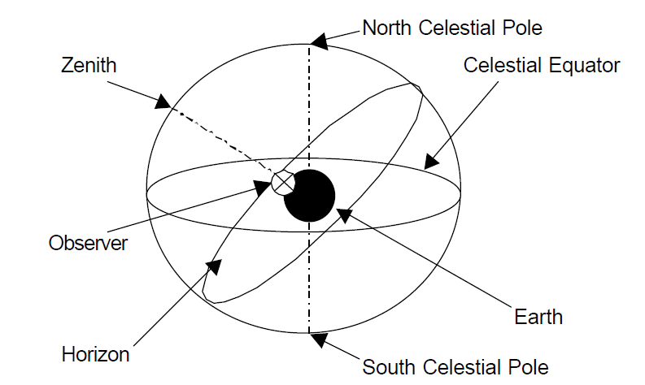

*Figure 1*: An illustrative view of the Celestial Sphere

**Ecliptic –** The name given to the Sun’s apparent path around the Earth during the year and labelled as such because lunar and solar eclipses occur when the Moon crosses this path.

**Zodiac –** A twelve-part division of the celestial sphere in the Ecliptic (see **Figure 2a**). Figure 2a shows the band of zodiac sign divisions, otherwise known as the Zodiac Belt (Sasportas, 1985). Figure 2b shows the birds eye view of the celestial sphere, in order to see the zodiac signs in full. The zodiac is most commonly used to describe the twelve zodiac signs.

*The following figure and note are each adapted from Heng Ser Guan’s research report* (2001, p. 10)

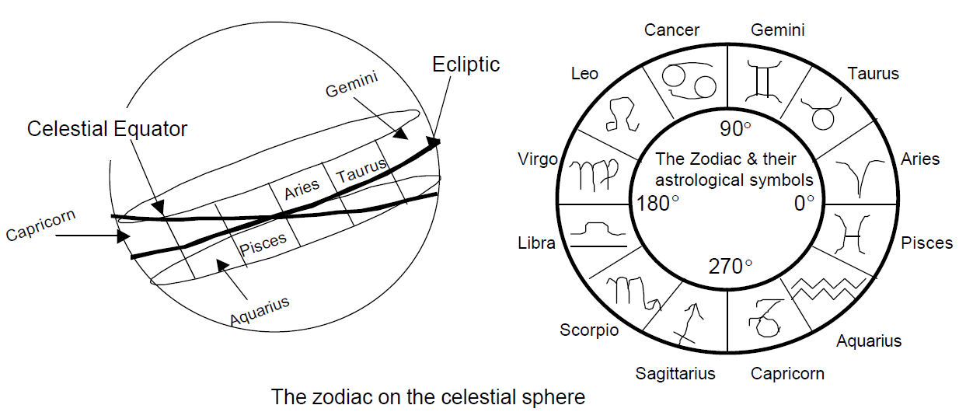

*Figure 2*. a) The Zodiac on the celestial sphere and b) the view from directly above the celestial sphere

**Zodiac Sign** – The name given to one twelfth division of the sky surrounding the Earth in a disc formation, for example Aries and Taurus are adjacent to each other. These are most popularly known as ‘star signs’.

**Planet** – Any celestial body orbiting the Earth from a geocentric perspective, for example the Sun, Moon, or Pluto. These are also further divided into types of planets. For the purpose of this research, focus is solely on the ‘Personal Planets’,

**Personal Planet** – These are the celestial bodies which are the closest, fastest moving and are therefore considered to have an immediate impact on daily experience, whereas the farther ‘Transpersonal Planets’ are considered to impact whole generations of individuals due to slower and therefore longer transits (Pluto spends 20 years transiting a sign). The personal planets are: Sun, Moon, Mercury, Venus and Mars.

**House** – The name given to one twelfth division of the horizon surrounding the Earth, in a disc formation, starting from a specific point related to the native’s birth information. For example, the first and second houses are adjacent to each other, always beginning at the point the Sun rises on the horizon at the time of birth.

**Polarity** – The dichotomous division of the 12 signs into negative and positive (See **Table 1)**. These divisions relate to shared qualities of being.

**Modality** – The division of the 12 signs into 3 groups; Cardinal, Fixed and Mutable (See **Table 1)**. These divisions relate to shared qualities of being

**Element** – The division of the 12 signs into 4 groups; Water, Earth, Air and Fire (See **Table 1)**. These divisions relate to shared qualities of being

Table 1. *A tabulated depiction of the 3 divisions of zodiac signs: Polarity, Modality and Element.*

|  |  |  |  |  |
| --- | --- | --- | --- | --- |
|  | **Positive** | | **Negative** | |
|  | **Fire** | **Air** | **Earth** | **Water** |
| **Cardinal** | Aries | Libra | Capricorn | Cancer |
| **Fixed** | Leo | Aquarius | Taurus | Scorpio |
| **Mutable** | Sagittarius | Gemini | Virgo | Pisces |

**References**

Butler, J. V., Guiso, L., & Jappelli, T. (2014). The role of intuition and reasoning in driving aversion to risk and ambiguity. *Theory and Decision*, *77*(4), 455–484. https://doi.org/10.1007/s11238-013-9407-y

Carleton, R. N., Norton, M. A. P. J., & Asmundson, G. J. G. (2007). Fearing the unknown: A short version of the Intolerance of Uncertainty Scale. *Journal of Anxiety Disorders*, *21*(1), 105–117. https://doi.org/10.1016/j.janxdis.2006.03.014

Clarke, D., Gabriels, T., & Barnes, J. (1996). Astrological signs as determinants of extroversion and emotionality: An empirical study. *Journal of Psychology: Interdisciplinary and Applied*, *130*(2), 131–140. https://doi.org/10.1080/00223980.1996.9914995

Cochrane, D. (2002). *Astrology for the 21st Century*. (V. Thompson, Ed.) (1st ed.). Florida: Cosmic Paterns Software, Inc.

Cooper, G. M. (2011). Galen and astrology: A mésalliance? *Early Science and Medicine*. https://doi.org/10.1163/157338211X557084

Erdfelder, E., FAul, F., Buchner, A., & Lang, A. G. (2009). Statistical power analyses using G*Power 3.1: Tests for correlation and regression analyses. *Behavior Research Methods*. https://doi.org/10.3758/BRM.41.4.1149

Ertel, S. (2009). Appraisal of Shawn Carlson ’ s Renowned Astrology Tests. *Journal of Scientific Exploration,*.

Eysenck, H. J. (1979). Astrology – Science or Superstition. *Encounter*. https://doi.org/10.1016/0191-8869(83)90094-6

Eysenck, S. B. G., Eysenck, H. J., & Barrett, P. (1985). A revised version of the psychoticism scale. *Personality and Individual Differences*, *6*(1), 21–29. https://doi.org/10.1016/0191-8869(85)90026-1

Fourie, D. (1984). Self-Attribution Theory and the Sun-Sign. *The Journal of Social Psychology*, *122*, 121–126.

Francis, L. J., Lewis, C. a, & Ziebertz, H. (2006). The short-form revised Eysenck personality Questionnaire (EPQ-S): A German edition. *Social Behavior and Personality an International Journal*. https://doi.org/10.4103/0972-6748.57854

Heng Ser Guan, K. (2001). *The Mathematics of Astrology - Does House Division Make Sense?*

Kwak, H., Jaju, A., & Zinkhan, G. M. (2015). Astrology: Its influence on consumers’ buying patterns and consumers’ evaluations of products and services. In *Developments in Marketing Science: Proceedings of the Academy of Marketing Science Annual Conference* (pp. 94–98).

Lee, J., & Paik, M. (2006). SEX PREFERENCES AND FERTILITY IN SOUTH KOREA DURING THE YEAR OF THE HORSE. *Demography*. https://doi.org/10.1353/dem.2006.0015

Lewis, S. (2015). *Astrological Psychology, Western Esotericism, and the Transpersonal*. (B. Hopewell, Ed.) (1st ed.). Cheshire: HopeWell.

Pellegrini, R. J. (1973). The Astrological ‘Theory’ of Personality; an unbiased test by a biased observer. *Journal of Psychology*, *83*, 21–28.

Sasportas, H. (1985). *The Twelve Houses*. (F. Clifford, Ed.) (Second). London: Flare Publications.

Sugarman, H., Impey, C., Buxner, S., & Antonellis, J. (2011). Astrology Beliefs among Undergraduate Students. *Astronomy Education Review*. https://doi.org/10.3847/AER2010040

Tompkins, S. (2006). *The Contemporary Astrologer’s Handbook*. (J. Struthers & F. C. Clifford, Eds.). London: Flare Publications.

van Rooij, J. J. F. (1994). Introversion-extraversion: astrology versus psychology. *Personality and Individual Differences*. https://doi.org/10.1016/0191-8869(94)90243-7

Zimbardo, P. G., & Boyd, J. N. (2015). Putting time in perspective: A valid, reliable individual-differences metric. In *Time Perspective Theory; Review, Research and Application: Essays in Honor of Philip G. Zimbardo*. https://doi.org/10.1007/978-3-319-07368-2_2